|  |  |
| --- | --- |
| **DOKUMENTASI EKSTERNAL**  External Documentation |  |
| **PROYEK**  ***Project*** |
| **MATAKULIAH <** **COMP6176> –**  **< Human and Computer Interaction >**  ***Subject*** |
| SEMESTER GENAP 2019/2020 ***Even Semester Year 2019/2020*** |

## Judul Proyek

*Project**Title*

* **Xtream Chaser**

## Pendahuluan

*Introduction*

* Xtream Chaser is the name of the game that is currently being developed, the game is set to be released on December 10, 2020 in Indonesia. This website is developed by our team due to the request of our CEO, in order to help the game in promotional purpose. This website provides information about the game to our users, including the logo of the game. This website consists of 5 pages. The first page is our homepage, this page shows the overview information of the game, in the form of images and texts, so that the users can have an insight on our game, such as what genre the game is, how does the game graphic looks like, what can we do in this game, etc. The second page is our gallery page, this page shows the images of ongoing events and gameplay, along with the description of the images. The third page is our character page, which shows all of our playable characters, particularly his/her image, name, and background story. The fourth page is our lore page, which shows the lore’s image and story, or in other words, the world where this game takes place along with the history and system of the world when the events of this game occurs. And lastly, is our pre-register page, which provides the feature that enables the user of our website to pre-register as a beta tester for our game in the upcoming beta test.

## Dokumentasi

*Report / Documentation*

* **Homepage**

After the answer file has been unzipped, enter the directory kelompok8 > views and open the file on the browser (ex: chrome). After that, the homepage will be displayed like the image below. This is the homepage for the Xtream Chaser website.

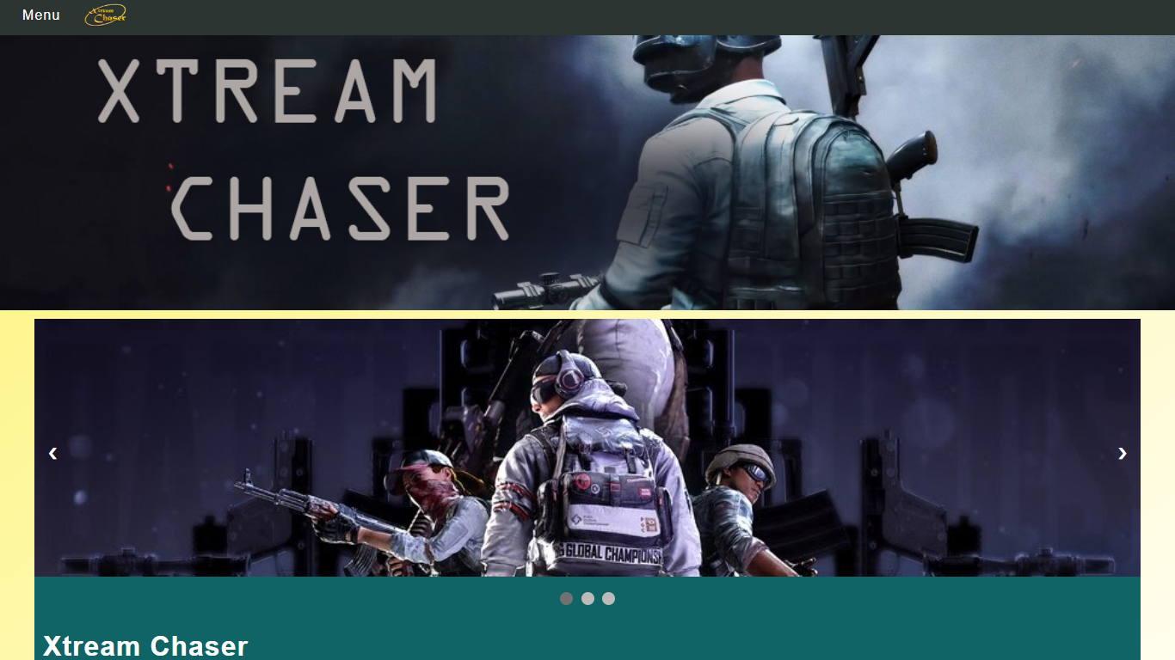

Homepage (upper) with slider on the 1st slide

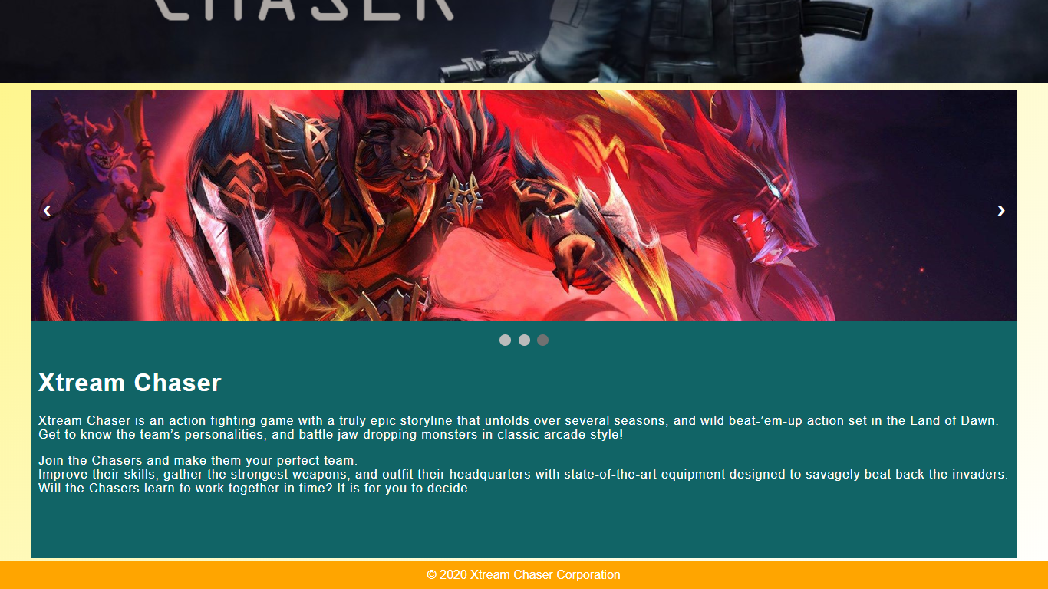

Homepage (lower) with the slider on the 3rd slide

The homepage is divided into 4 parts : navigation, header, boy, dan footer.

Navigation is located on the top of the page, with black colored bar and white colored font that writes “Menu”. When you hover on the menu, it will display the 5 page in drop down menu such as the image below. If the page on the menu is clicked, you will be redirected to that page. In addition, the navigation bar also has the logo for our game, which will redirect the user to our homepage when it is clicked, regardless of the page where the user is currently in.

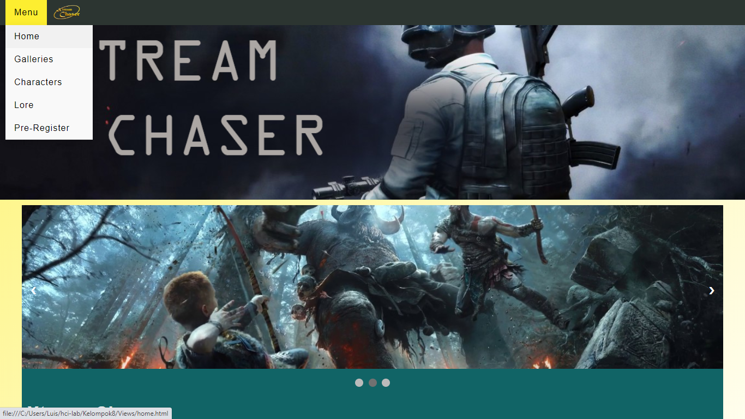

Homepage - menu

Below the navigation, there is a header that shows banner for the Xtream Chaser game, the banner the game title written on it.

Below the header, there is a body for the homepage, where there is an image-slider that is created and animated using jquery. There is a total of 3 image on the slider, and each image shows the overview of the game. Besides being animated, you can move to the next slide on your own accord by clicking the arrow on the left and right side of the slider, or the circle below the slider. Each circle represents 1 slide on the image-slider.

Below the image-slider, there is an information about the game itself, written in the form of paragraphs.

Below the body, there is a footer that shows the copyright of the website, which is owned by Xtream Chaser Corporation. The writing on the footer is “© 2020 Xtream Chaser Corporation”

Besides being designed for pc desktop, this website is also designed to be responsive. For screen with width below 800px, like on most mobile phone, the website design will be adjusted accordingly so that the image and information can be viewed comfortably, without losing any functionality. The example of the display for mobile phone can be seen below.

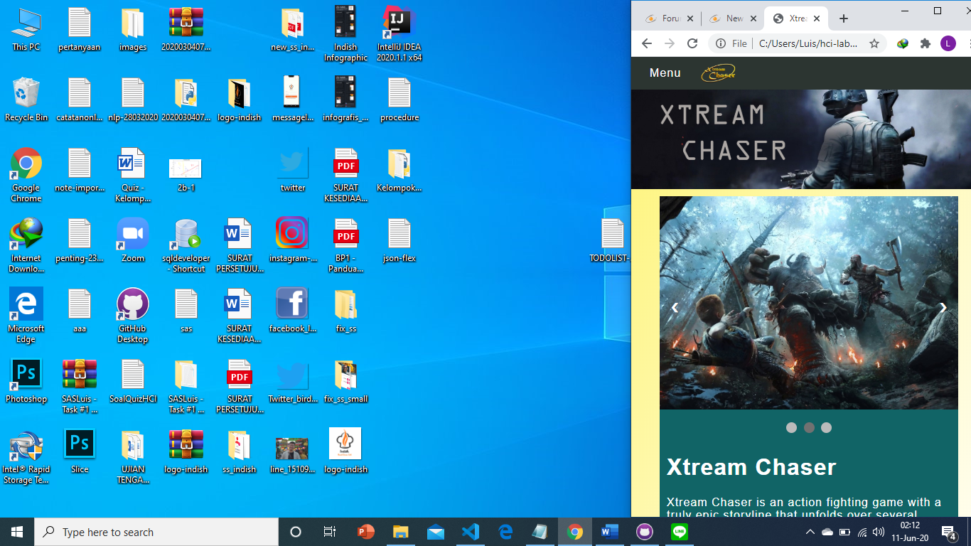

Homepage for mobile (upper)

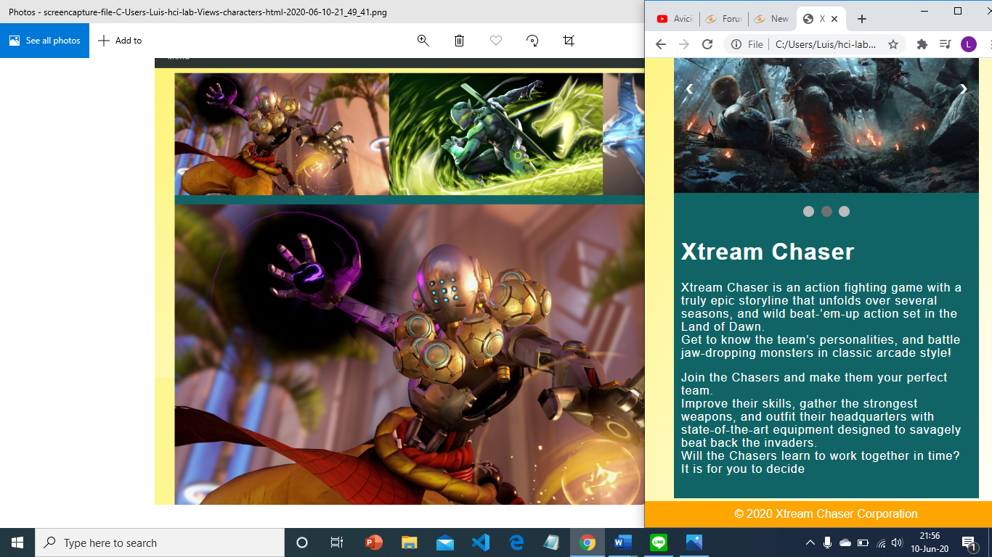

Homepage for mobile (lower)

* **Gallery**

To open the galleries page, please click on the page name on the menu that is mentioned above. On this page, you can view the images of Xtream Chaser’s gameplay and ongoing event.

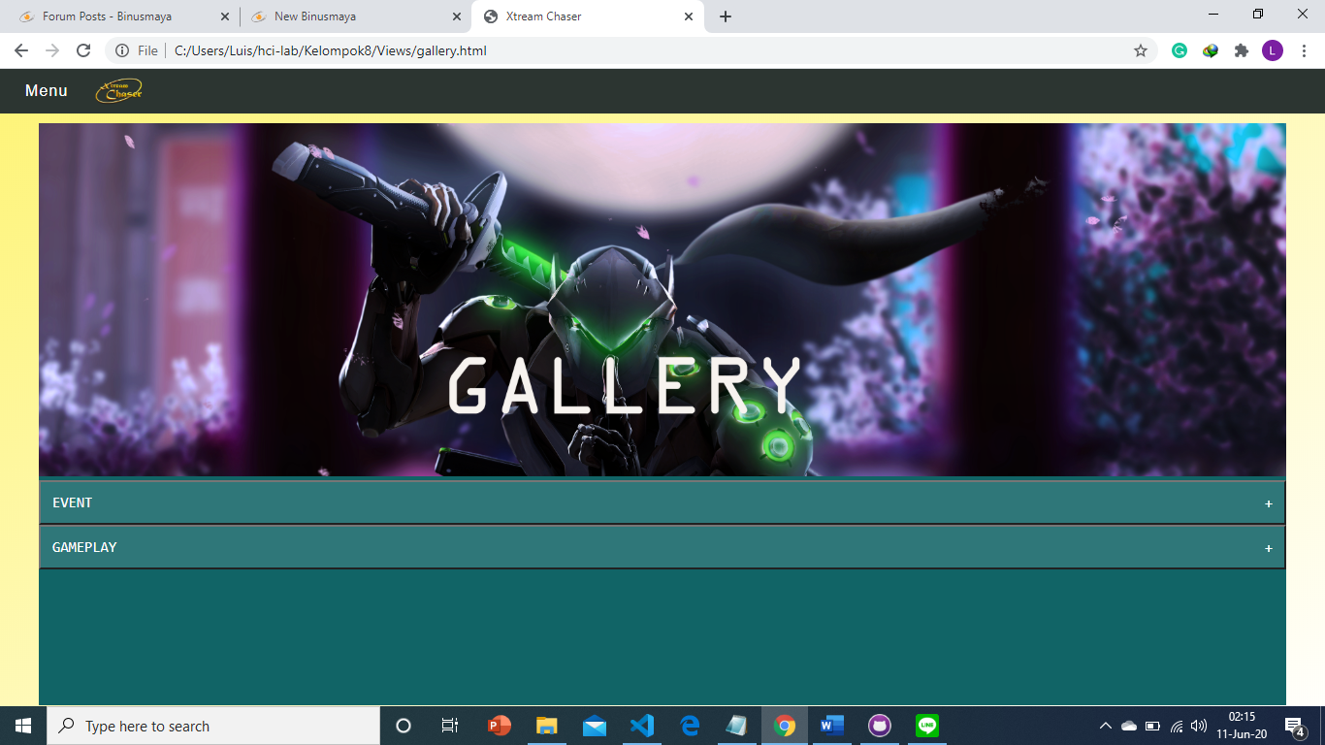

Gallery page

On the gallery page, there is also the same navigation bar on the top. Next, there is a banner for the page, with the image of the in-game character and the page name, which is “gallery”, this serves for promotional purpose. Under the banner, there is 2 collapsible bar, with both being collapsed when you first open the page. There are collapsible bar for event gallery, and gameplay gallery. The bar will be opened when you click on the bar, and then the images of the gallery will be displayed. When the bar is closed, the icon on the right of the bar will be shown as ‘+’, to indicate that the bar can be opened. After the bar is opened, the icon will be change to ‘-‘, which indicate the bar can be closed.

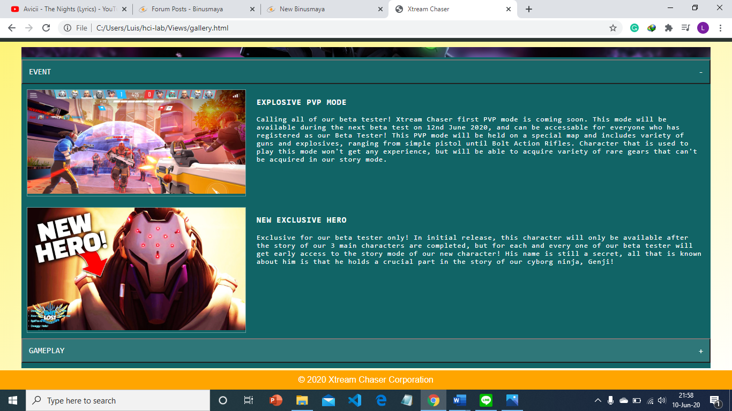

Gallery page 2

After you open the first collapsible bar, the gallery for all ongoing events will be displayed in the form of grid, one after another in sequence from top to below. For each event, there is the image of the event on the left, and the information on the right. As for the information, there is the title on the top, followed by the content below it. If you hover on the image, the cursor will be changed to pointer and the image will be highlighted, to indicate that the image can be clicked.

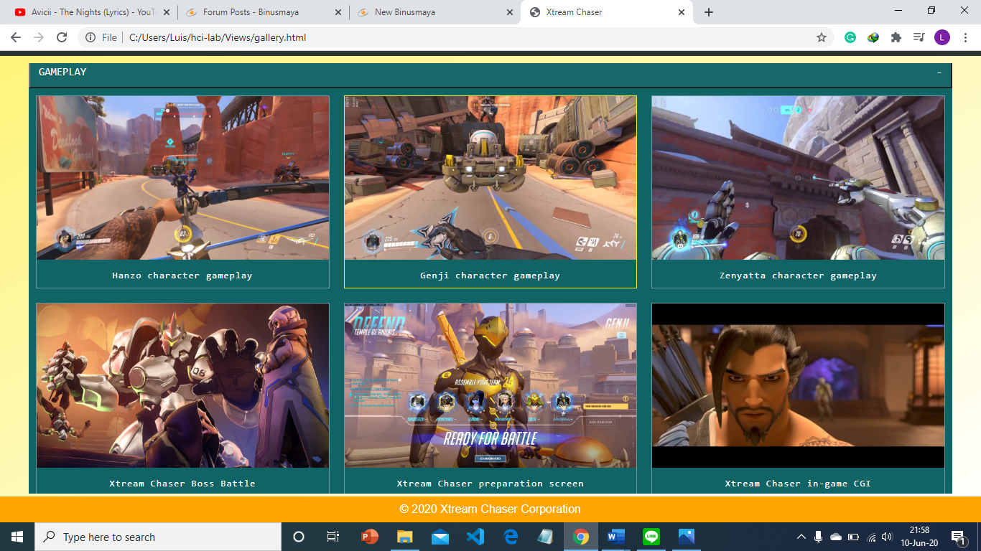

Gallery page 3

After you open the the second collapsible bar, the gallery for the gameplay of Xtream Chaser will be displayed in the form of grid, each row will be displayed in 3-column format, so there are 3 images for each row. For the 4th image, it will be displayed on the 2nd row, and so on. If you hover on the image, the cursor will be changed to pointer and the image will be highlighted, to indicate that the image can be clicked. In addition, there is also short description for the gameplay image under each image.

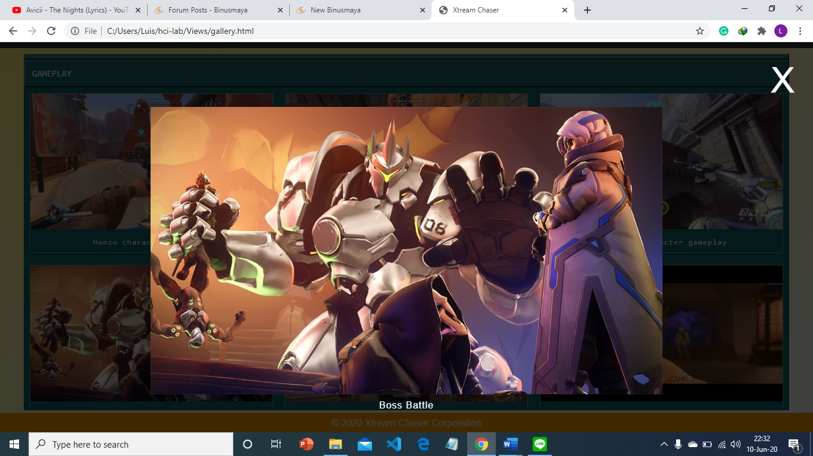

Gallery page – modal

If you click on any of the image of the gallery, a modal (dialogue box) component will pop up and show the larger version of the image on the center page, followed by a caption under the image. When the modal is open, the background will be darkened so that you can focus on the image that is being displayed. To close the modal, you can click the X button on the top right of the page.

This page also has a mobile version that will be displayed for the screen with the width below 800px.

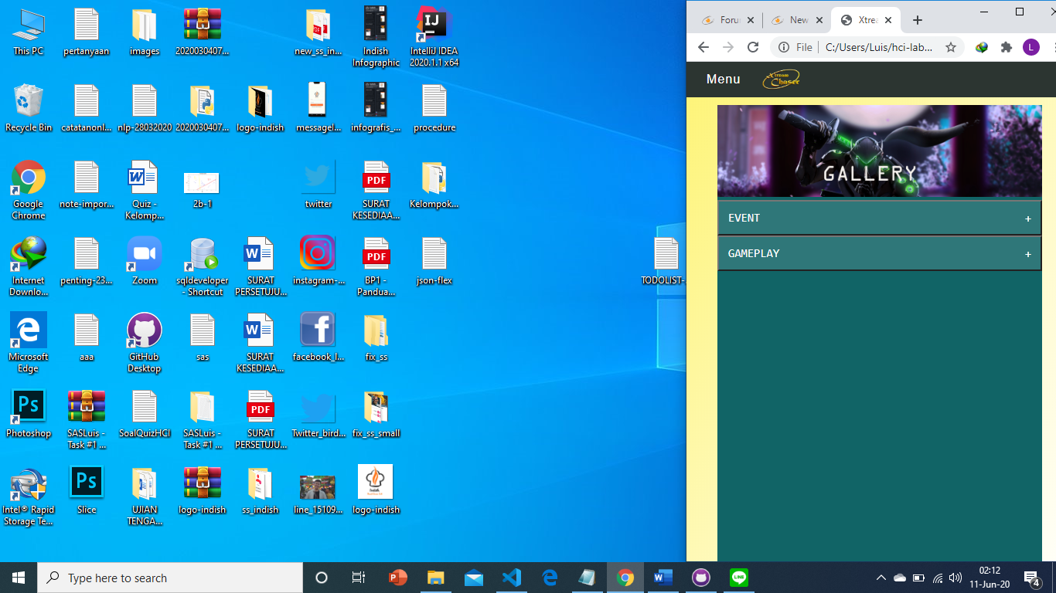

Gallery page for mobile 1

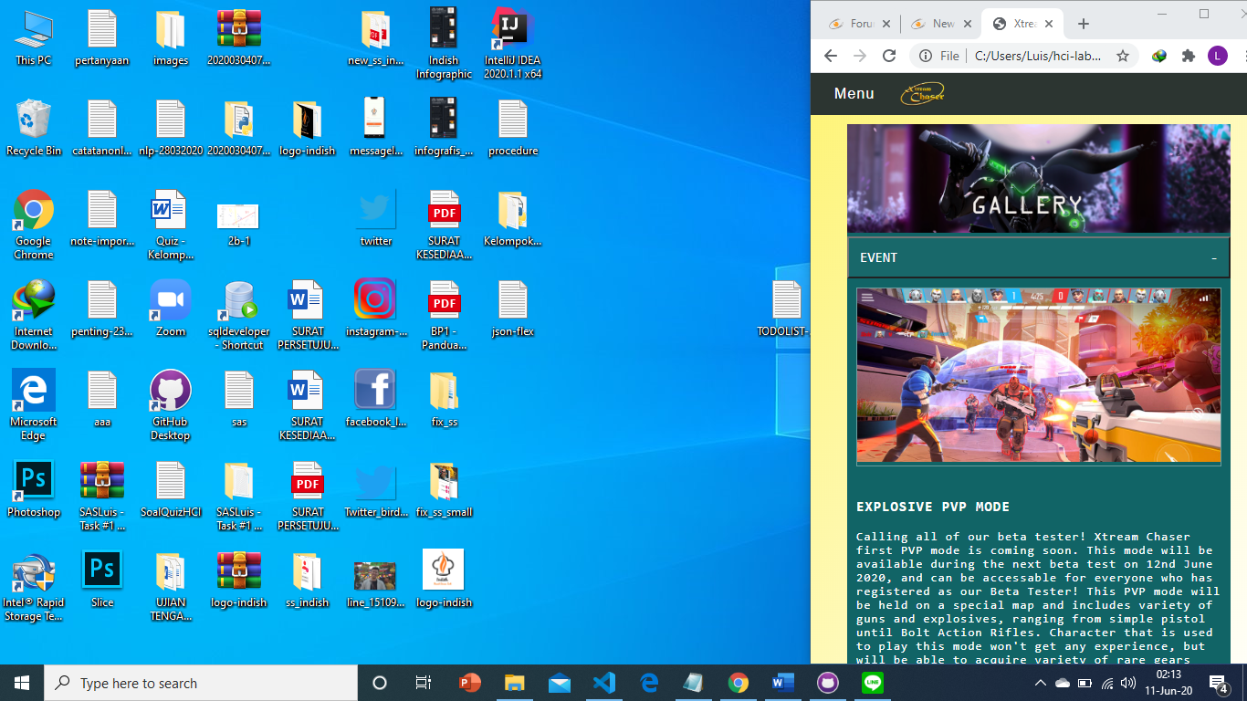

Gallery page for mobile 2

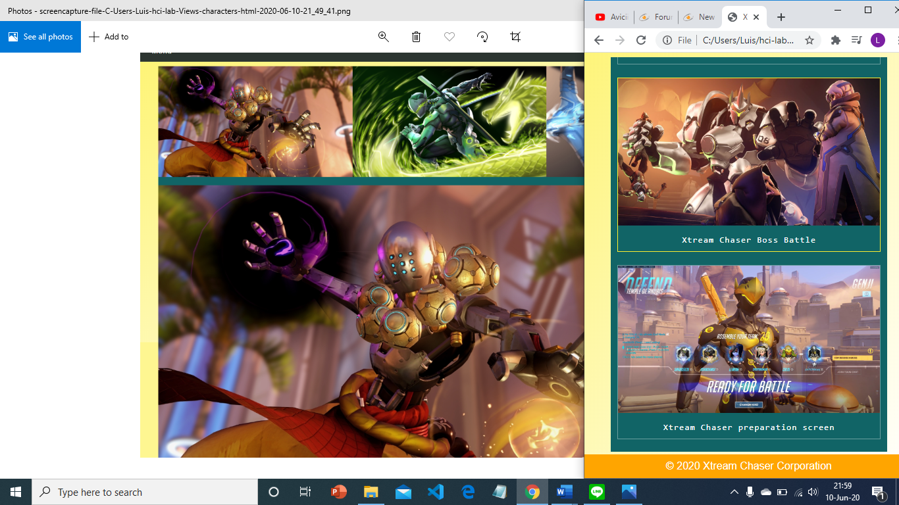

Gallery page for mobile 3

For the mobile version, the event gallery’s information is shown below the image instead of being shown on the right, and the gameplay gallery is shown in 1-column format instead of 3-column format.

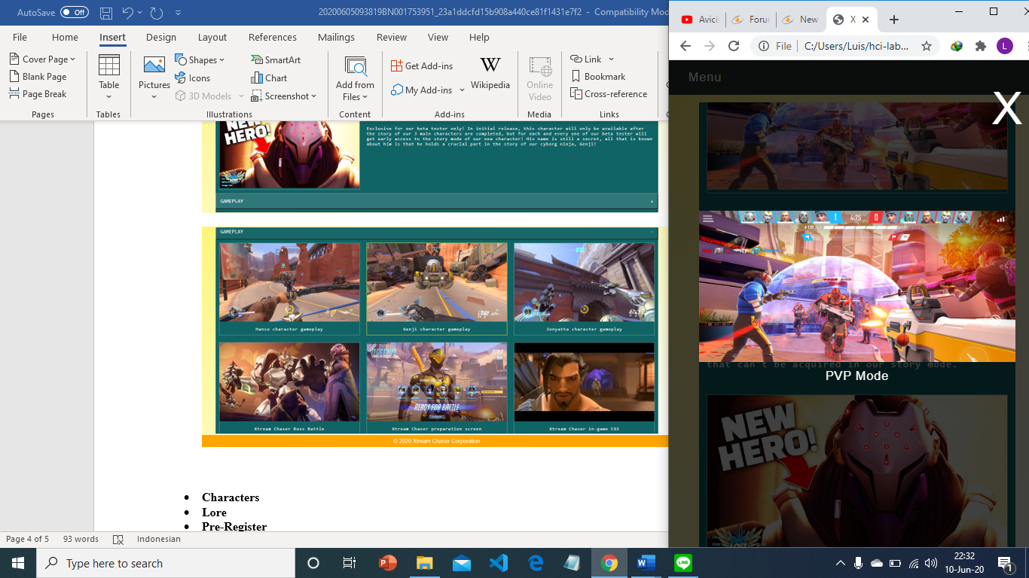

Gallery page for mobile - modal

* **Characters**

To open the character page, please click on the page name on the menu that is mentioned above. On this page, you can view the images and information of Xtream Chaser’s characters.

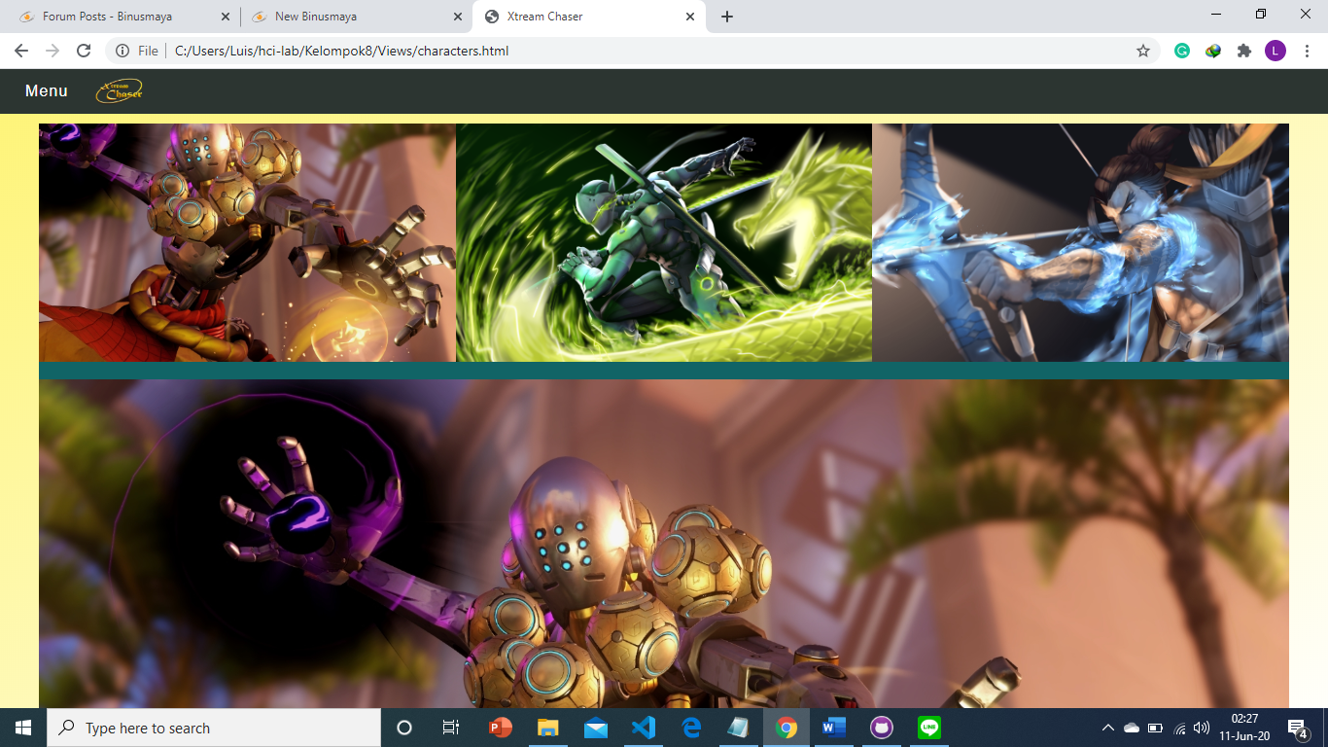

Character page (upper)

There is a total of 3 playable characters in Xtream Chaser, all 3 image of the characters is shown on the top of the body. These 3 images are shown side-by-side, and 1 of the larger version of the image is shown below, but this larger image only shows 1 of the character. As default, the left-most character will be shown as the larger image.

But you can change the character to be displayed as the larger image, by clicking on the smaller image of the respective character. When you hover on the smaller image, there is a zoom animation on the character that you hover on.

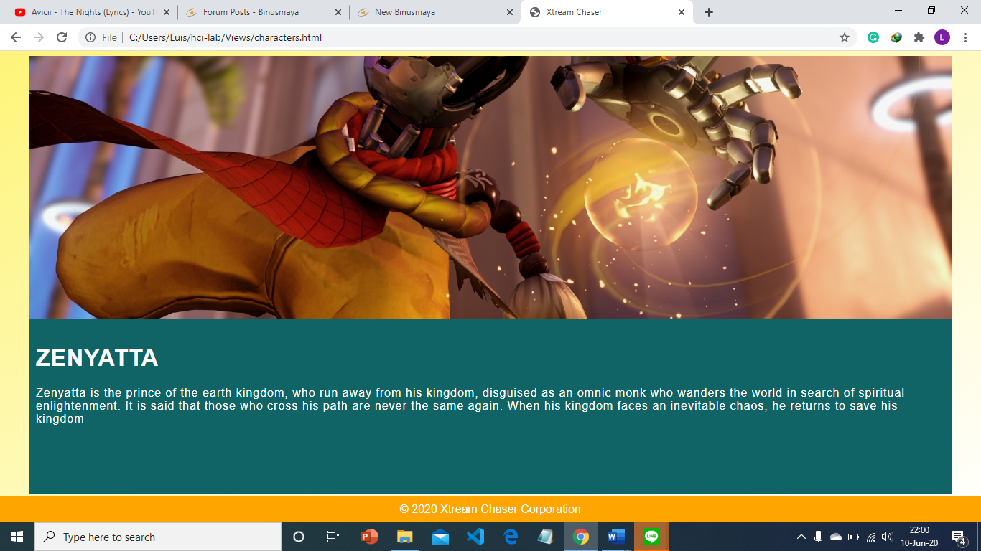

Character page (below)

Under the larger image, there is an information on the character that is currently displayed on the larger image. The information consists of the name and background story of the character.

This page also has a mobile version that will be displayed for the screen with the width below 800px.

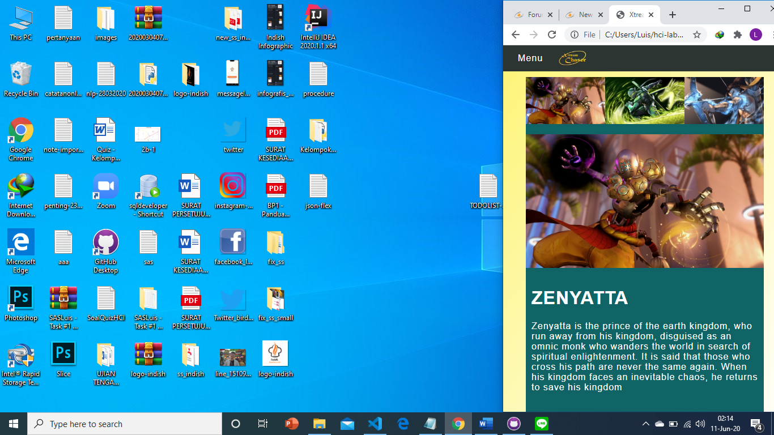

Character page for mobile

* **Lore**

To open the lore page, please click on the page name on the menu that is mentioned above. On this page, you can view the information regarding the lore’s image and the lore’s story.

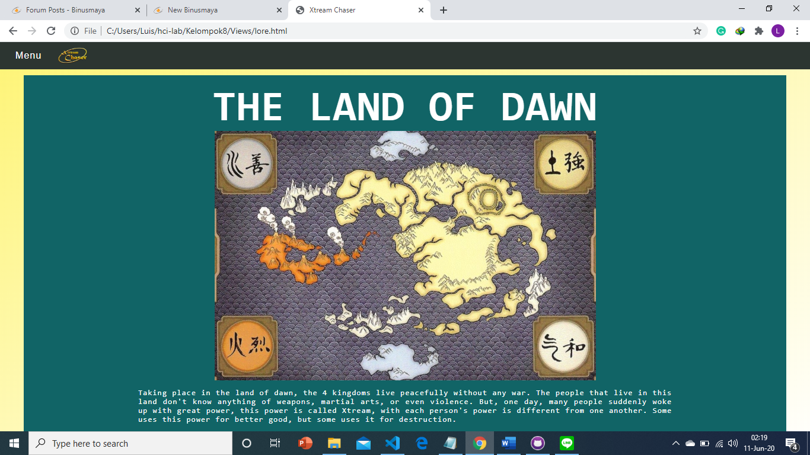

Lore Page 1

On top of the body, there is the name of the world where this game takes place, the lore’s name is aligned in the center of the page.

Below it, there is the image of the world map where this game takes place, every kingdom and location in the game are shown in this map.

Below the image, there is the lore’s story, shown in the form of paragraphs.

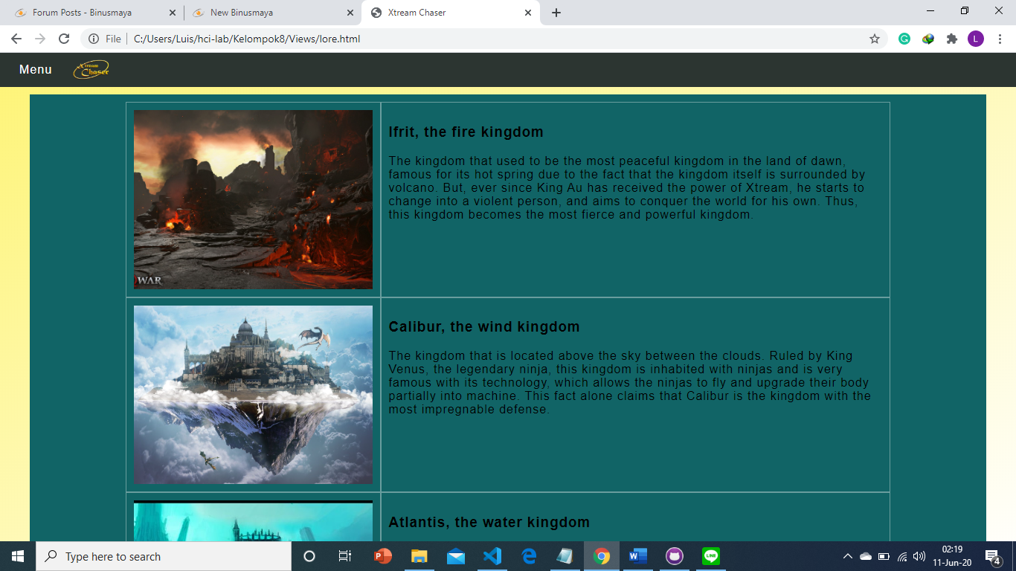

Lore Page 2

Below the lore’s story, there is more specific information on the kingdoms that existed within the game. The kingdom’s name, image, and story are displayed on this part. This is shown in the grid format, the kingdom’s image is shown on the left, and the information on the kingdom is shown on the right. On the top, there is the name of the kingdom, followed by the story of the kingdom below it, the story is shown in paragraph. Each kingdom’s image and information are displayed in different row, one after another, in sequence.

This page also has a mobile version that will be displayed for the screen with the width below 800px.

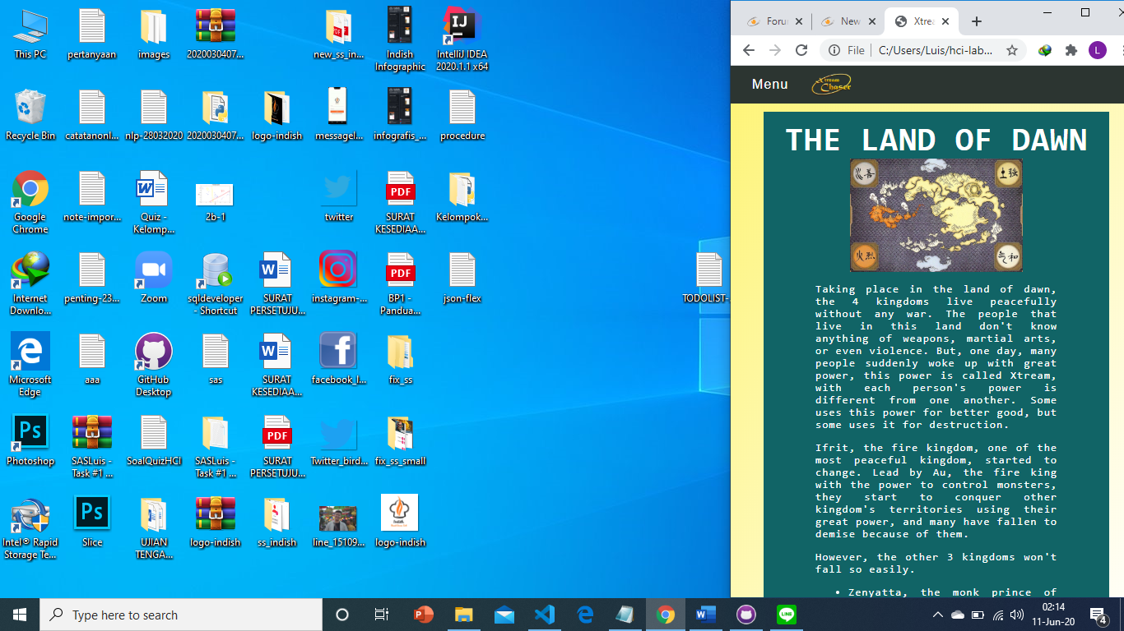

Lore page for mobile 1

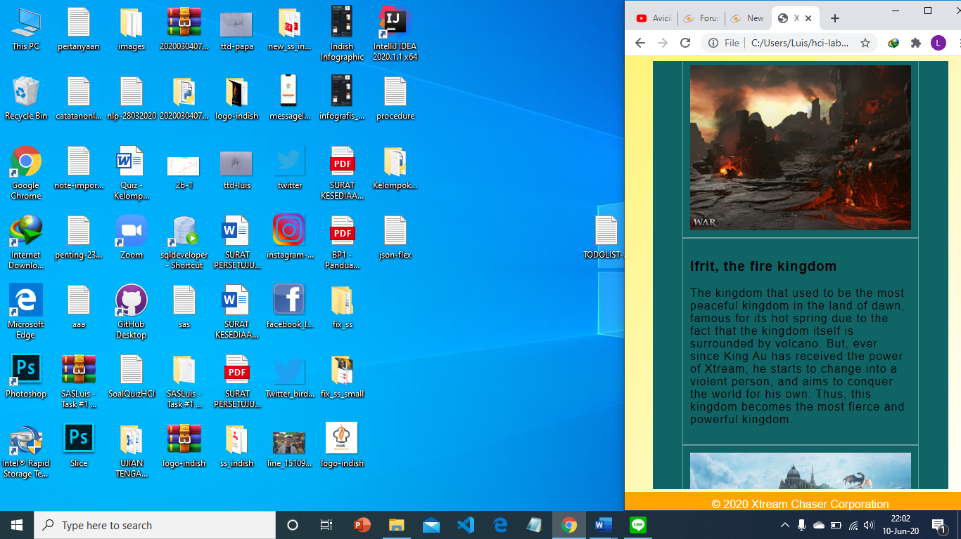

Lore page for mobile 2

For the mobile version, the kingdom’s information is shown below the image instead of being shown on the right,

* **Pre-Register**

To open the pre-register page, please click on the page name on the menu that is mentioned above. On this page, you can pre-register as a beta tester of this game.

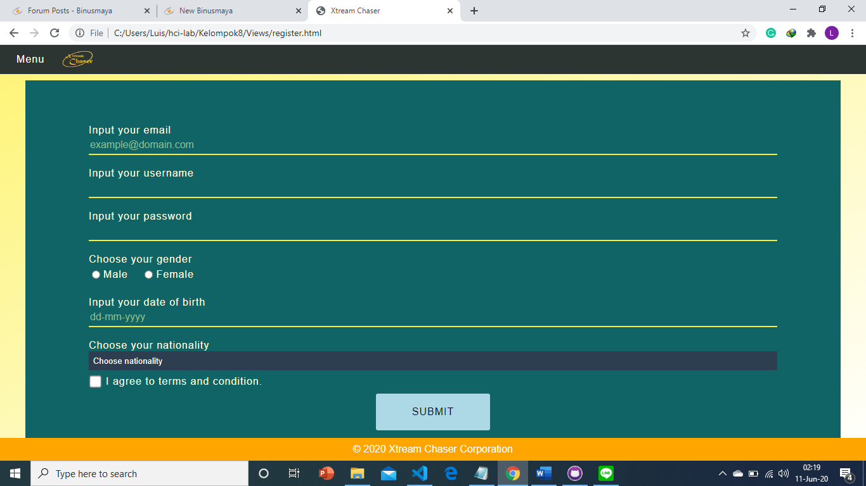

Pre-register page

In order to pre-register as a beta tester, user has to fill in the form that consists of email, username, password, gender, date-of-birth, and nationality. Each of the input comes with its own validation that is unique to other inputs. As for email, username, password, and date-of-birth, user has to type the input himself/herself on the given space. Meanwhile, gender comes with a radio button, so the user just has to click on one of the two radio buttons. And for nationality, the input can be chosen from the dropdown list. If the user’s nationality is not included in the dropdown list, user can choose other. In addition, ser also has to check the “I agree to terms and conditions” box by clicking the box or the text.

The email has to be in the correct format, such as having the character ‘@’ and a dot after at least 3 letters from ‘@’ and cannot be at the end of email.

The username must be between 3 – 20 characters long.

The password must be at least 8 characters long and must contain at least one digit, one lowercase, and one uppercase letter.

User must choose the gender between male and female.

The date of birth is a text input with the format dd-mm-yyyy. This format has to be followed or the system will not accept the data. The date of birth also cannot be equal or less than 3 years old from this year.

Nationality is a dropdown that must be chosen. If you leave it empty or ‘Choose nationality’, the system will not accept the data.

Then user must check the checkbox to agree to the terms and condition applied.

After user has finished filling the form, the user has to click the submit button. And then, the user’s input will be validated. If the user input doesn’t meet the required condition or format, the warning message will be displayed. Else, an alert that displays the message that the pre-register is successful will be shown, and user will be redirected to the homepage.

This page also has a mobile version that will be displayed for the screen with the width below 800px.

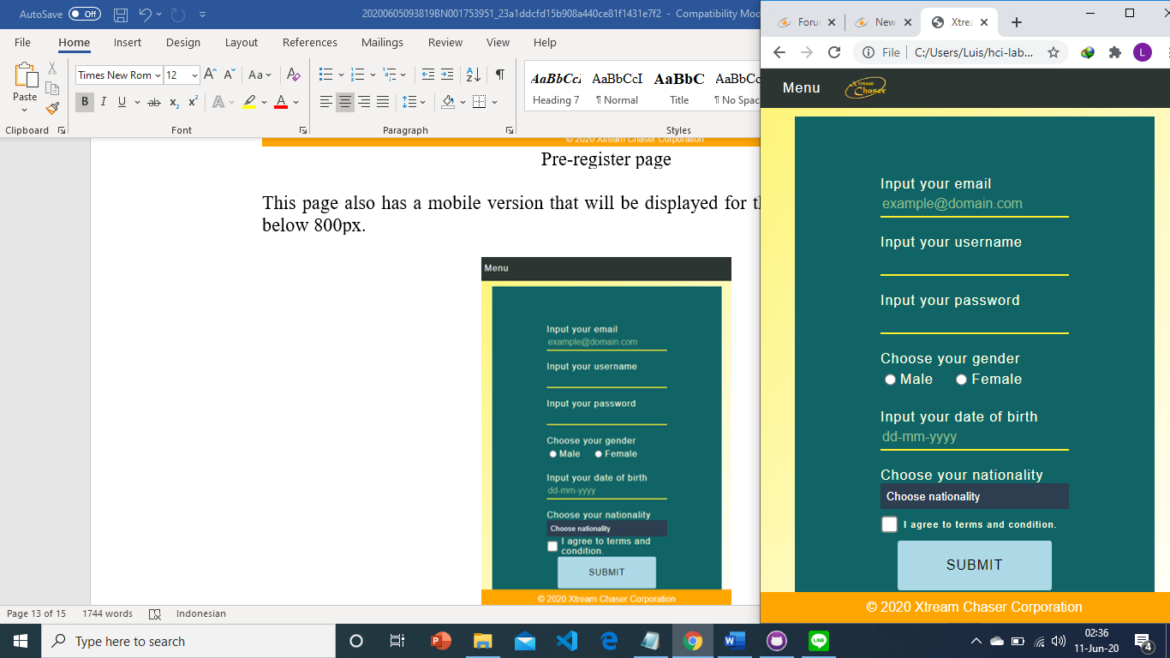

Pre-register page for mobile

## References

* **https://www.pinterest.com/pin/92746073558752282/**
* **https://www.youtube.com/watch?v=EogYyhqWI_0**
* **https://steamcommunity.com/sharedfiles/filedetails/?id=1545902783**
* **https://www.uhdpaper.com/2019/10/pubg-global-championship-2019-4k-7259.html**
* **https://cdn1.dotesports.com/wp-content/uploads/2018/08/11171853/f63d9158-60d0-4191-bde6-deb783c3ef86.jpg**
* **https://p4.wallpaperbetter.com/wallpaper/219/72/59/video-game-overwatch-hanzo-overwatch-wallpaper-preview.jpghttps://p4.wallpaperbetter.com/wallpaper/219/72/59/video-game-overwatch-hanzo-overwatch-wallpaper-preview.jpg**
* **https://i.pinimg.com/originals/bc/8f/08/bc8f08e7f91d737f144893e6fb2b6ea0.jpg**
* **https://i.pinimg.com/originals/f3/27/fb/f327fb77be03c53e6a44ee2985d325c8.jpg**
* **https://i.pinimg.com/originals/4f/6c/db/4f6cdb2efc31e51a00d88430142f5aca.jpg**
* **https://i.pinimg.com/originals/2b/9b/41/2b9b4133698e1526d5a733f0008115ed.jpg**
* **https://images.alphacoders.com/704/thumb-1920-704039.png**
* **https://kafubackup.s3.eu-central-1.amazonaws.com/uploads/tournaments/resized/banner1585767273.jpg**
* **https://i.ytimg.com/vi/oHMwBjeA_ls/maxresdefault.jpg**
* **https://i.ytimg.com/vi/ICYze2ezj6A/maxresdefault.jpg**
* **https://i.ytimg.com/vi/BLyUFhuGsVs/maxresdefault.jpg**
* **https://i.ytimg.com/vi/EAUDxYXdSD8/maxresdefault.jpg**
* **https://i.ytimg.com/vi/9_9YGRMLB0k/maxresdefault.jpg**
* **https://i.ytimg.com/vi/fQjrx_O88_o/maxresdefault.jpg**
* **https://esports-news.co.uk/wp-content/uploads/2019/11/shadowgun-war-games-1024x490.jpg**
* **https://i.ytimg.com/vi/hk6GtmoqOmg/maxresdefault.jpg**
* **https://www.w3schools.com/css/css_image_gallery.asp**
* **https://www.w3schools.com/howto/howto_css_modal_images.asp**
* **https://www.w3schools.com/howto/howto_js_collapsible.asp**
* **https://images6.alphacoders.com/704/704120.png**
* **https://i.pinimg.com/originals/cb/fe/fb/cbfefbb6710e9e7817de1d66e0155a6f.jpg**
* **https://vignette.wikia.nocookie.net/sea-of-clouds/images/5/5d/Xaphan.jpg/revision/latest?cb=20170618205923**
* **https://i.pinimg.com/originals/b8/0b/4c/b80b4c40bc7793ce3385504a0a8ebd37.jpg**
* **https://cdnb.artstation.com/p/assets/images/images/013/297/897/large/aenok-oh-2.jpg?1538989121**
* **https://cdna.artstation.com/p/assets/images/images/000/561/624/large/kobe-sek-photo-19-4-14-7-27-38-am.jpg?1426823144**

Disiapkan Oleh,

*Prepared by,*

* **<2201758934> - <Luis Indracahya >**
* **<2201788634> - <Stephen Leonardo >**
* **<** **2201808125> - < Leo Christopher Coo>**